 

Dear Parent(s) and Guardian(s),

We have recently implemented a new feature of SwiftK12, allowing us to send report cards and other important documents via your email address(es). In order to ensure success with the new feature, **it’s important we have a current email address on file for your family**.

To review and update your contact information, please log-in to your PowerSchool Parent Portal at: [insert URL here].

Once logged in, click on the SwiftReach SwiftK12 link on your left navigation pane under Alerting:

: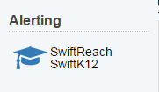

Please make any data changes necessary via the Contact Information section and then click *Save Changes.*



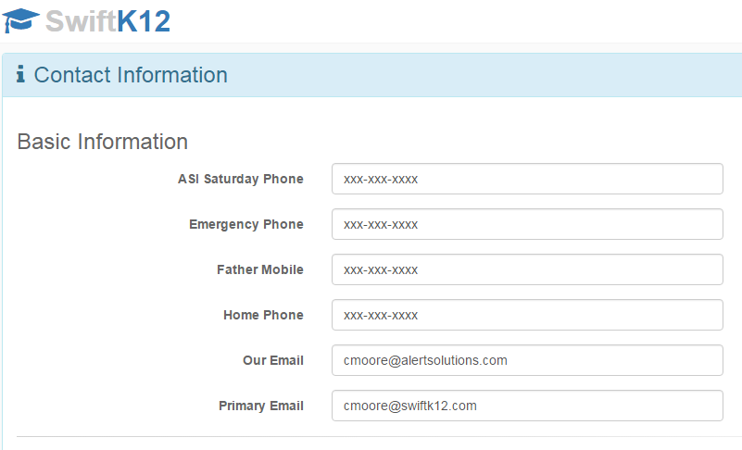



If you are unable to update your contact information for any reason, please feel free to contact the school office and we can update the information for you.

If you have any questions, please feel free to contact _________ at ____-____-______.

Thank you,

(Contact's Name)

(Contact's Title)

(School's Name)

(School's Email)

(School's Phone)